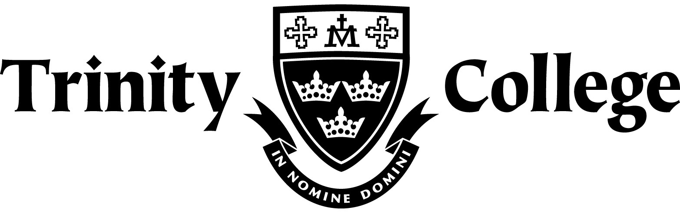

Chemistry

Organic Chemistry Test

# DO NOT MARK THIS PAPER

**Multiple choice 10 marks**

1. Which of the following is **not** a pair of isomers?

A. ethyl benzene (C6H5-C2H5) and dimethyl benzene, C6H4(CH3)2

B. 1-propanol (CH3CH2CH2OH) and 2-propanol (CH3CHOHCH3)

C. ethanol (C2H5OH) and dimethyl ether (CH3OCH3)

D. 2-butanone (CH3COCH2CH3) and 1-butanol (CH3CH2CH2CH2OH)

2. Which reagents react to give ethyl benzoate (C6H5COOC2H5) and water? The structure of ethyl benzoate is given below.



3. In which of the following alternatives are the three compounds listed in order of increasing boiling point?

A. Pentane, butan-1-ol, propanoic acid

B. Propanoic acid, butan-1-ol, pentane

C. Propanoic acid, pentane, butan-1-ol

D. Butan-1-ol, propanoic acid, pentane

4. The raspberry-flavoured food additive, butyl methanoate, can be prepared from CH3CH2CH2CH2OH using

A. an addition reaction with HCOOH.

B. an addition reaction with CH3COOH.

C. a condensation reaction with HCOOH.

D. a condensation reaction with CH3COOH.

5. Which compound is least soluble in water?

A. CH3CH2CH2F

B. CH3CH2CH2NH2

C. CH3CH2CH2OH

D. CH3CH2CH2COOH

6. How many different aldehydes have the formula C5H10O?

A. 2

B. 3

C. 4

D. 5

7. The boiling points of CH3COCH3, CH3COC2H5, and CH3COC3H7 are 56 °C, 80 °C, and

102 °C, respectively. This increase is best attributed to an increase in which of the following?

**I dipole-dipole interactions**

**II dispersion forces**

**III hydrogen bonding**

A. I only

B. II only

C. III only

D. II and III only

8.Which of the following statements would apply to compounds that belong to the same

homologous series?

**I they have similar physical properties**

**II they have similar chemical properties**

**III they contain the same functional group**

**IV they have the same molecular formula but different structures**

A. III only

B. IV only

C. II and III only

D. I, II, III and IV

9. Pure samples of which of the following exhibit hydrogen bonding?

**I CH3OH**

**II CH3NO2**

**III CH3CN**

A. I only

B. I and II only

C. II and III only

D. I, II, and III

10. The compound that is **not** an isomer of 2,2,4-trimethylpentane is

A. octane

B. 3-ethylhexane

C. 2,4-dimethylpentane

D. 2,4-dimethylhexane

1. Give the IUPAC name of the following structures:

(a)



(b)



(c)



(d)



(e)



(f)

CH3CH2CH2COONa

[6 marks]

2. Give the full structural formula for the following organic chemicals:

(a) 1,2,3 - propantriol

(b) 6-amino-7-bromo-3-heptanone

(c) 2-ethylhexyl ethanoate

(d) *cis-*oct-3-ene

(e) *trans*-3-heptene

(f) 2,4-dimethylpentan-1-amine

[6 marks]

3. For each of the situations described below, determine whether or not a redox reaction would be expected and, if so:

(i) Write a balanced redox reaction showing the changes that take place;

(ii) Give a brief observation that would be expected to accompany the reaction.

(a) Acidified potassium permanganate solution is added to 2-methyl-3-pentanol.

(b) Limited acidified potassium dichromate is added to hexanol.

[8 marks]

4. DRAW and NAME the major organic PRODUCT or PRODUCTS in the following reactions assuming appropriate conditions. NB. No balancing is required.

(a) Ethanol and pentanoic acid with H2SO4 as a catalyst.

(b) Ethane and chlorine.

(c) Bromine and Benzene in the presence of UV light.

(d) Pentene and hydrogen chloride in the presence of a catalyst

[8 marks]

6. (a) Elementary analysis of a compound indicated that it contained only carbon, hydrogen, nitrogen and oxygen. A 1.279g sample was burned completely in oxygen such that all the carbon was converted to carbon dioxide and the hydrogen to water. This resulted in 1.600g of carbon dioxide and 0.770g of water. A separate 1.279g sample was shown by analysis to contain 0.1697g of nitrogen. Calculate the empirical formula of the compound.

(b) Given that the molecular mass of the compound was found to be 105g.mol-1, determine the molecular formula.

(c) Given that the compound is a primary amine, reacts rapidly with sodium metal yielding an alkanoate and can be neutralized with NaOH, draw a possible structure.

[8 marks]